**Mild to Moderate evaluation:**

Sample_Id:**XWHY66(cat)**

Link:<https://release.animalbiome.com/pet/assessment/report/summary/12563c56-e477-4c2b-b1cc-77c4fc0b1bc1>

Mild to Moderate:

Cats and dogs:

Any Two

(High Yellow Flag Megamonas OR (failed)

High Yellow Flag Sutterella OR (failed)

High Yellow Flag Collinsella OR (failed)

Low Yellow Flag Bacteroides OR (failed)

Low Yellow Flag Blautia (failed)

)

OR Cats: 8-10 Yellow Flags(Passed)8

OR 5-8 Red Flags;(Failed)1

OR dietary recommendation of increase fiber (**failed**)

or protein or decrease carbs(**Failed**)

Or Escherichia High(**failed**)

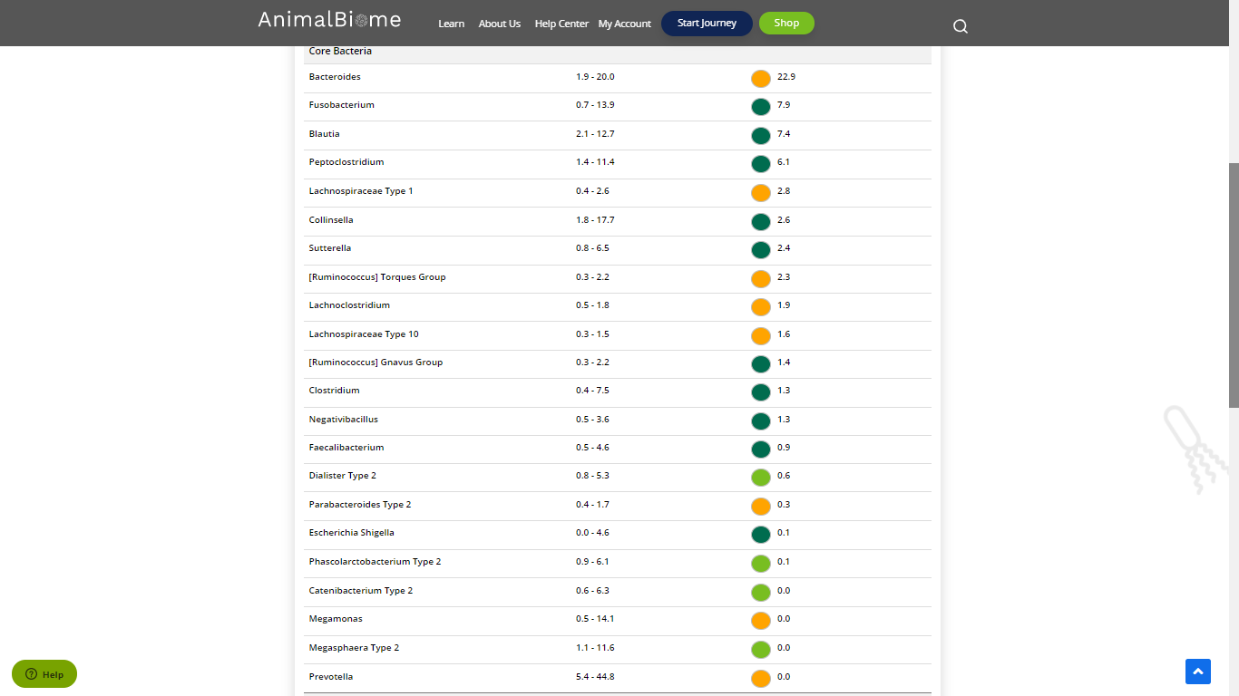

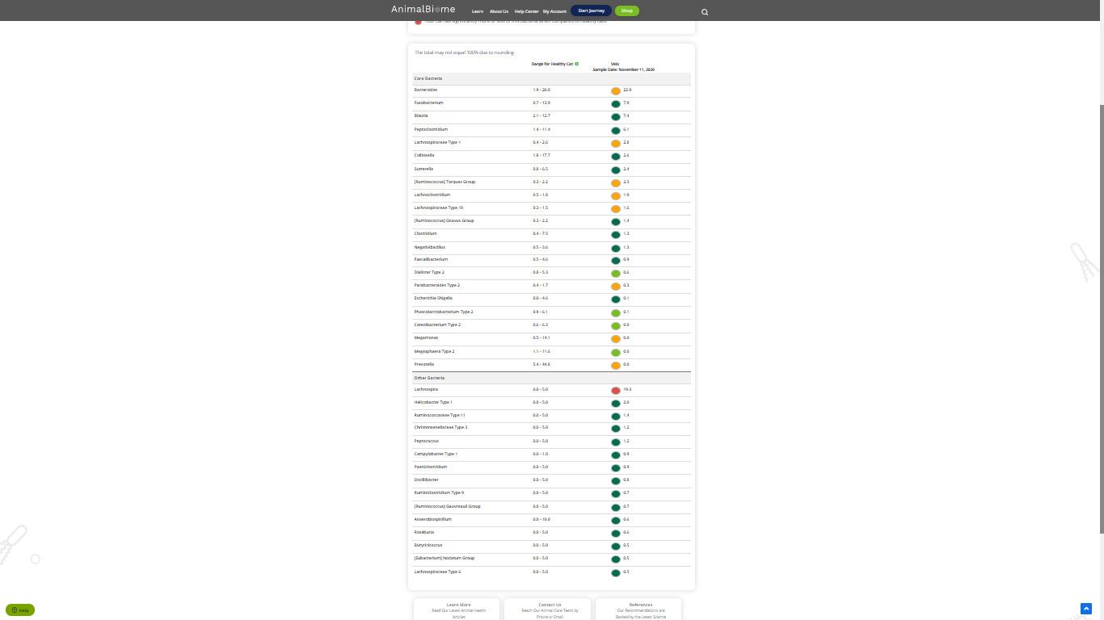

The result : **False** **True False False**

Mild to moderate evaluation results:Pass

Expected result : Mild to moderate

Achieved result : **passed.**

